**Home assignment**

Capstone design course

OpenCV with Python

1. From image ***gray_car.png*** manually find the position of a SUV car and draw a rectangle as following:

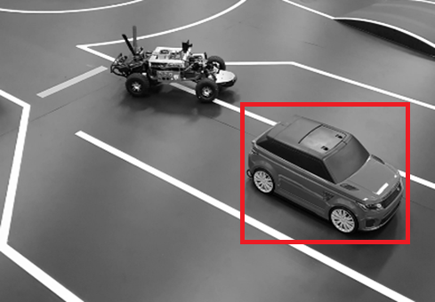

Save resulted image.

1. Using ROI separate ***gray_car.png*** image into two different images as following:

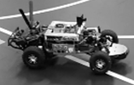 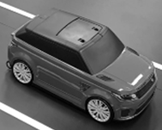

Save resulted images

1. Create blurred and sharpen images from ***gray_car.png*** image. Save resulted images
2. Using histogram equalization increase the brightness of the ***gray_car.png*** image. Save resulted images

Submit the code in one file. Comment each task accordingly. If you think you can’t submit in one file use commenting method. Submit all the files in archive (zip) format and include the explanation document file.